|  |
| --- |
| **Phase-6**  **Full stack java developer**  **Capstone project**  **Project :-Food Box**  **(Application Screenshots)** |

**Version History**

|  |  |
| --- | --- |
| Author | K.Swathi |
| Purpose | Screenshots of the Application |
| Date | 01/02/2022 |
| version | 1.0 |

Table of Content: Pg.No.

**Admin Login ............................................................... .......................................................... 3**

**Orders list............................. .................................................................................................. 3**

**Admin Home...............................................................................................................................4**

**View Users...................................................................................................................................4**

**Add Recipe..................................................................................................................................5**

**View Recipe.................................................................................................................................6**

**View Feedback............................................................................................................................7**

**Users Flows**

**Web Home page.........................................................................................................................8**

**View Famous Food Items..........................................................................................................8**

**View Famous Food Items..........................................................................................................9**

**Check for Offers.........................................................................................................................9**

**Special Offers.............................................................................................................................10**

**User Registration.......................................................................................................................10**

**User details for Registraion......................................................................................................11**

**Validating User Form................................................................................................................11**

**Login Page(after successful registration)..................................................................................12**

**User Login...................................................................................................................................12**

**User Home...................................................................................................................................13**

**Search for the Item.....................................................................................................................14**

**Search for the Item.....................................................................................................................15**

**Buy Now......................................................................................................................................15**

**Go to cart to check out...............................................................................................................16**

**Click on Check out for payment...............................................................................................16**

**Provide card details(credit/debit).............................................................................................17**

**Payment Successful page...........................................................................................................17**

**Order Successful confirmation.................................................................................................18**

**User Profile Settings...................................................................................................................19**

**-2-**

**Click on My Profile....................................................................................................................19**

**Click on Edit Profile...................................................................................................................19**

**Edit Profile...................................................................................................................................20**

**To Change Password .................................................................................................................20**

**To Change Password .................................................................................................................21**

**Forgot Password ........................................................................................................................21**

**Forgot Password ........................................................................................................................22**

**Feedback ......... ............................................................................................................................22**

**Contact and Feedback Form .....................................................................................................23**

**Logout ..........................................................................................................................................24**

**Git hub:-**

**Login to github by providing the email address and password**

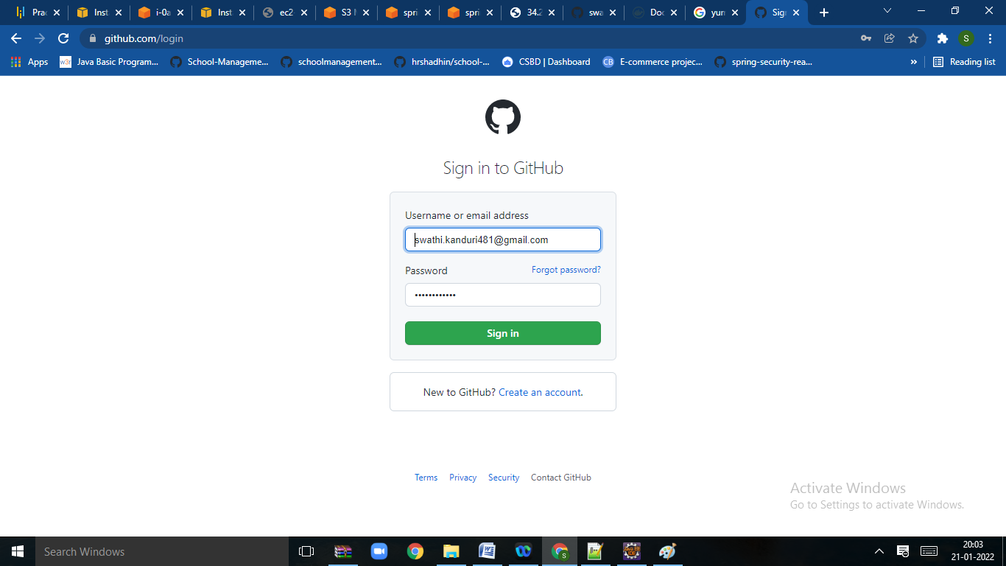

**Click on sign in option to open the page**

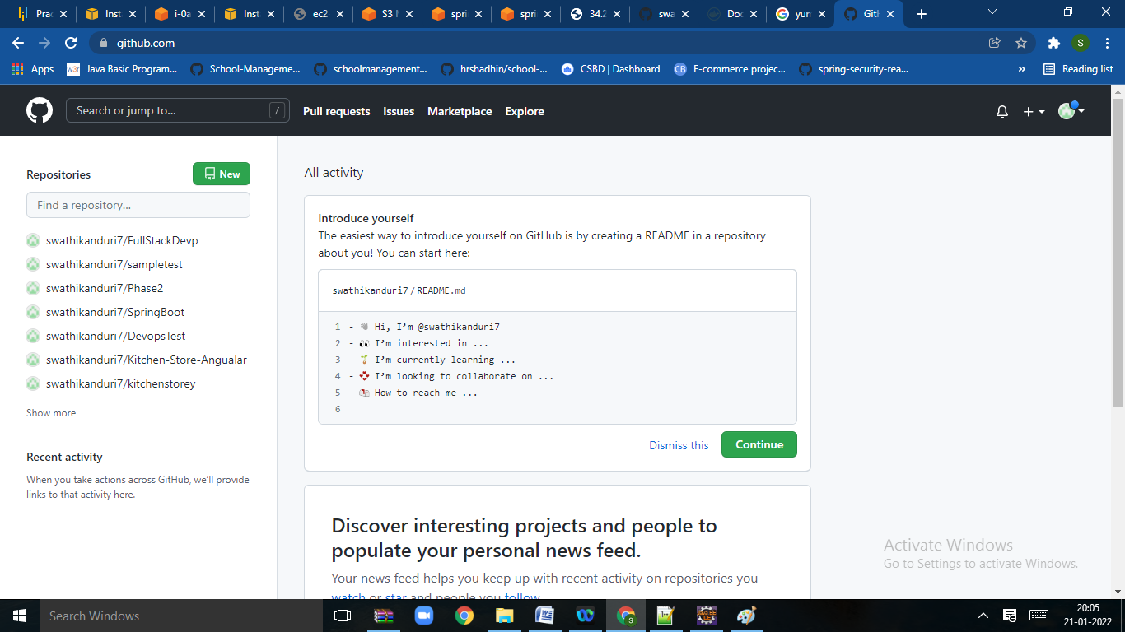

**Click on new repository to create new repository**

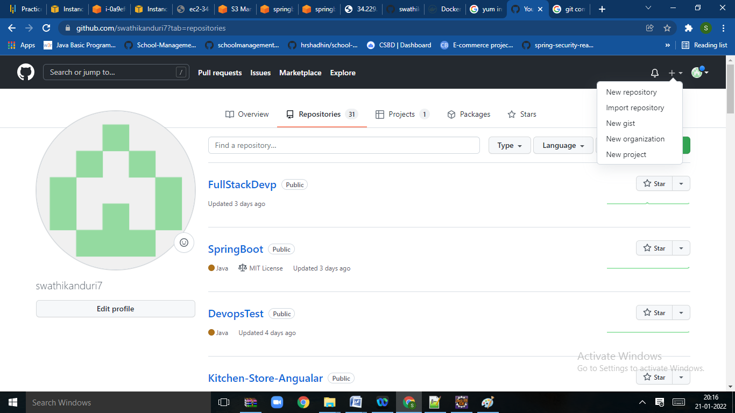

**Give the repository name and select create repository**

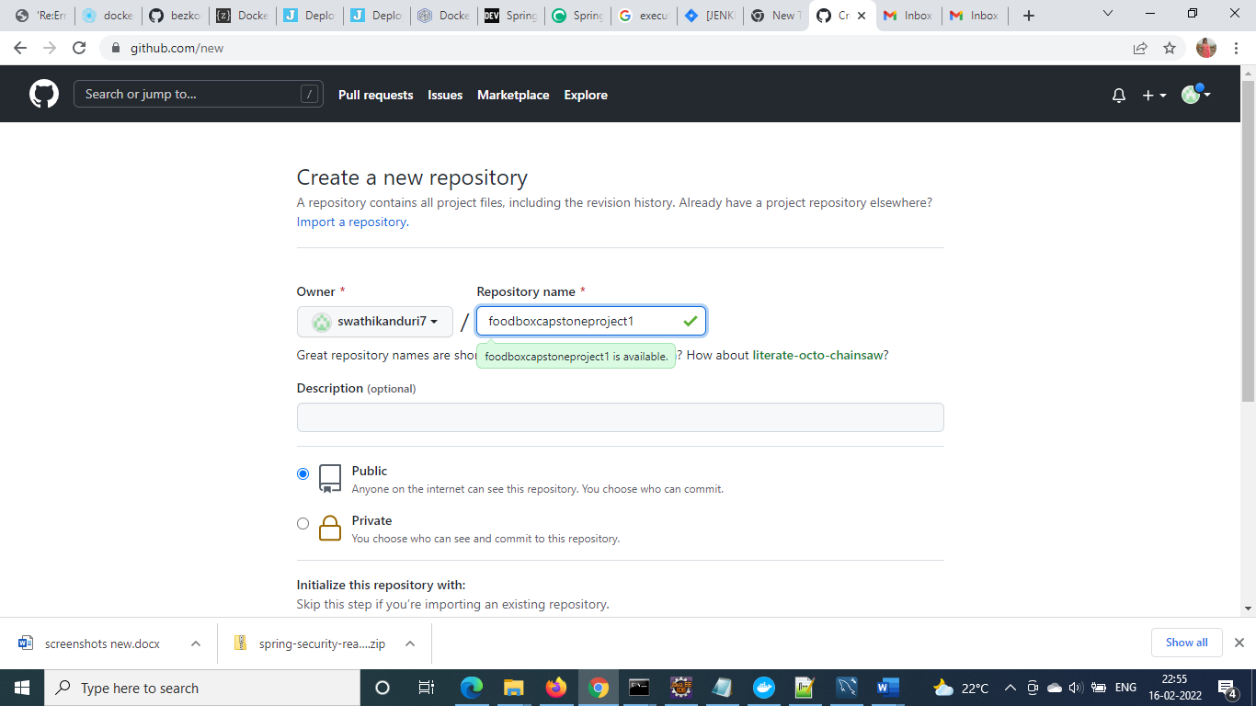

**Steps to Push the code to Git Hub Repository**

* Open your command prompt and navigate to the folder where you have

created your files.

**cd <folder path>**

* Initialize repository using the following command

**git init**

* Add all the files to your git repository using the following command

**git add .**

* Commit the changes using the following command

**git commit . –m<commit message>**

* Push the files to the folder you initially created using the following command

**git push -u origin master**

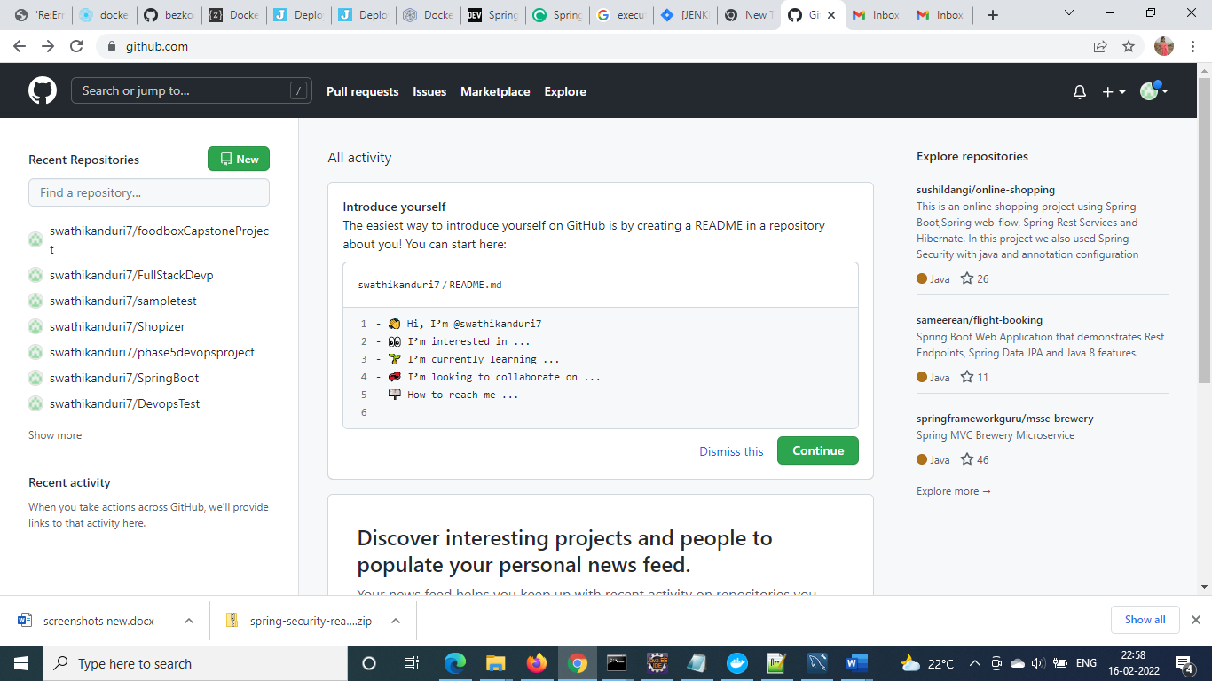

**Code pushes to the git hub**

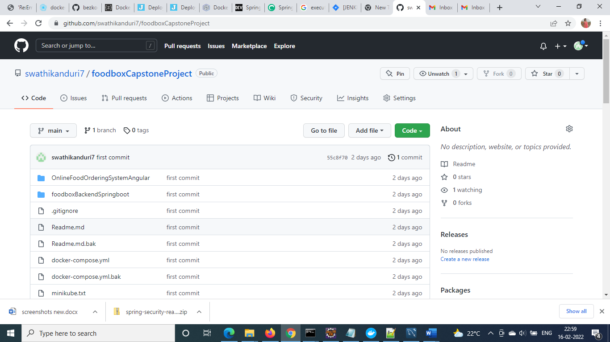

**Jenkins Job**

**step1:- New item**

**give the name of the job**

**select free project**

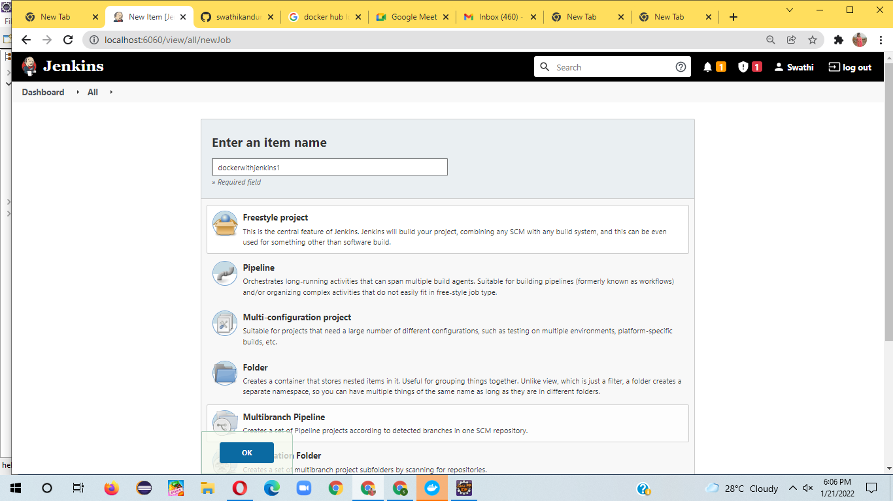

**config git url:-**

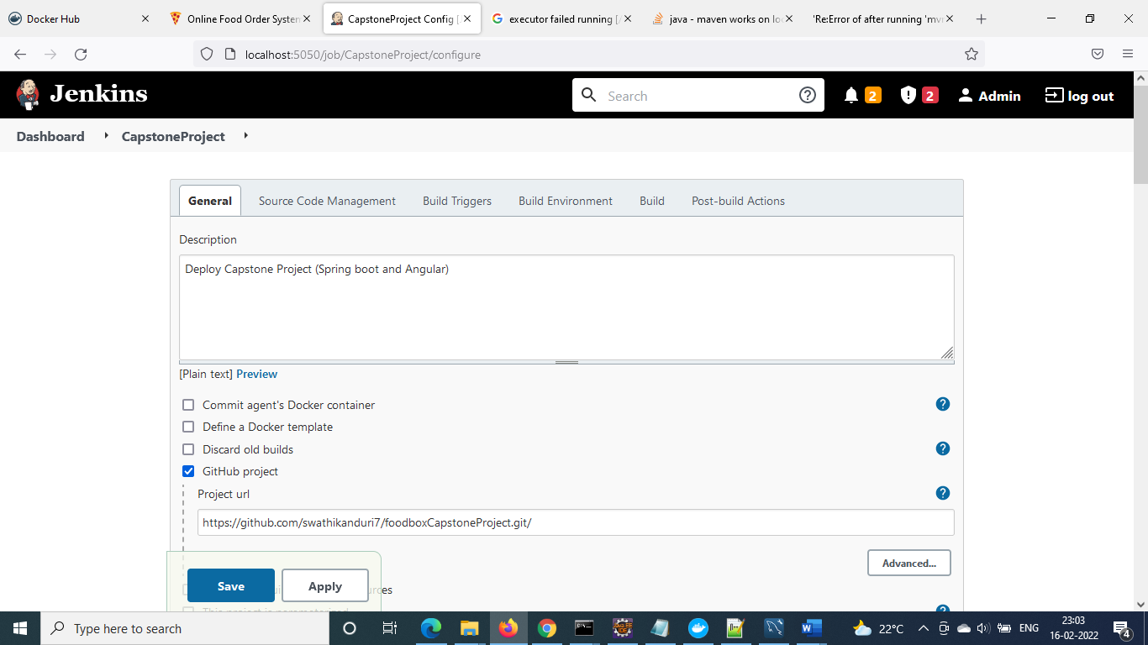

**config scm**

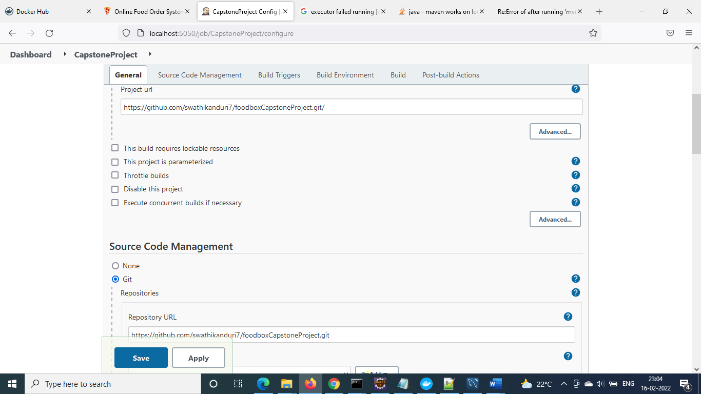

**config build trigger rule, branch name**

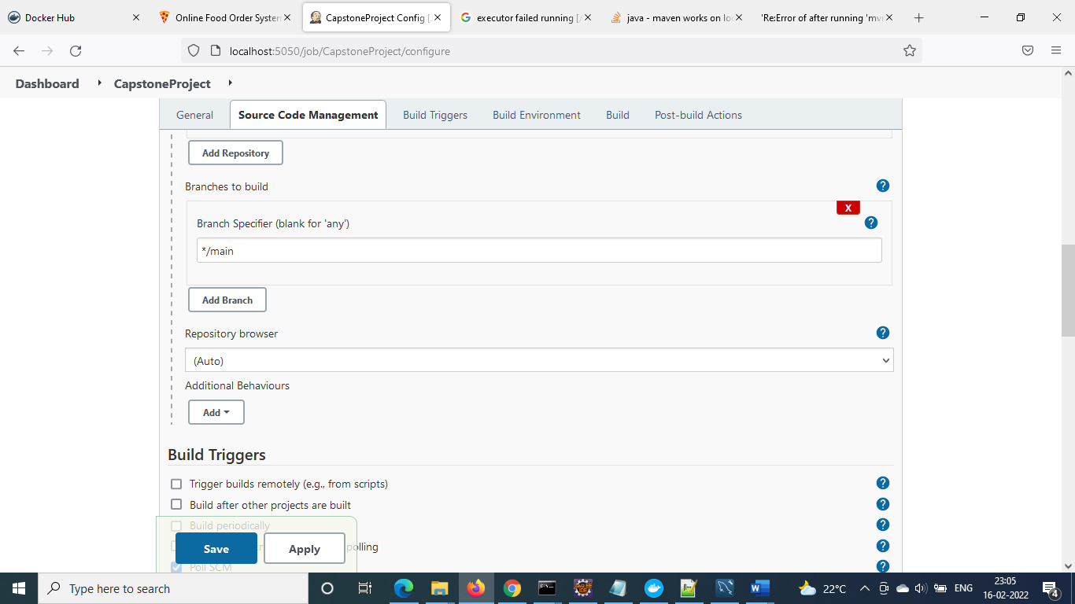

**Build Triggers**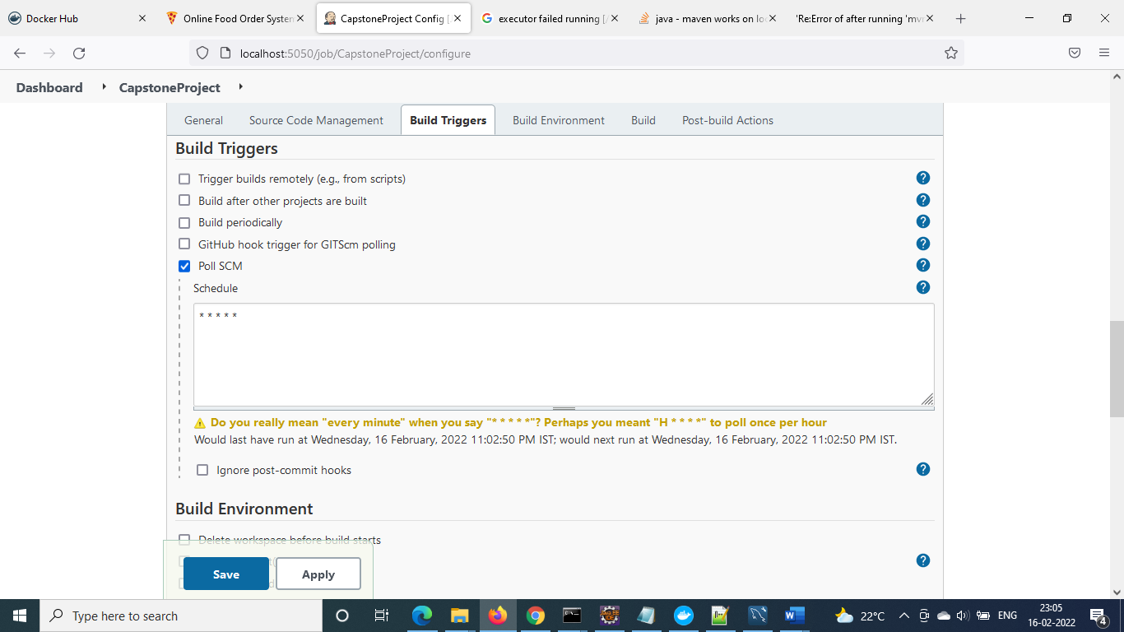

**configure docker build and push and click on save to update the details**

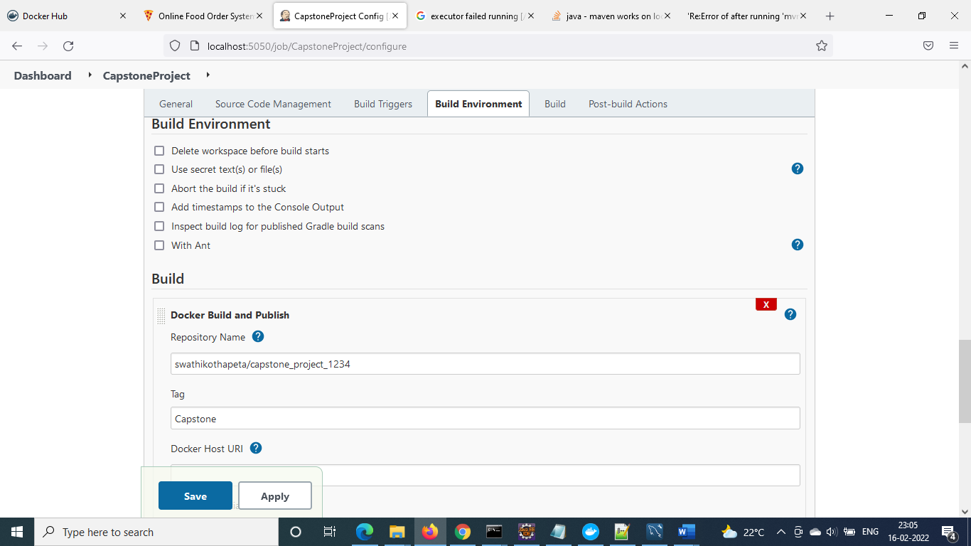

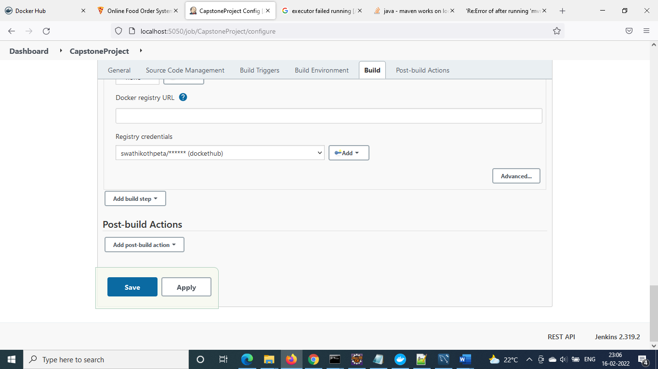

**Trigger jenkins job, using build now**

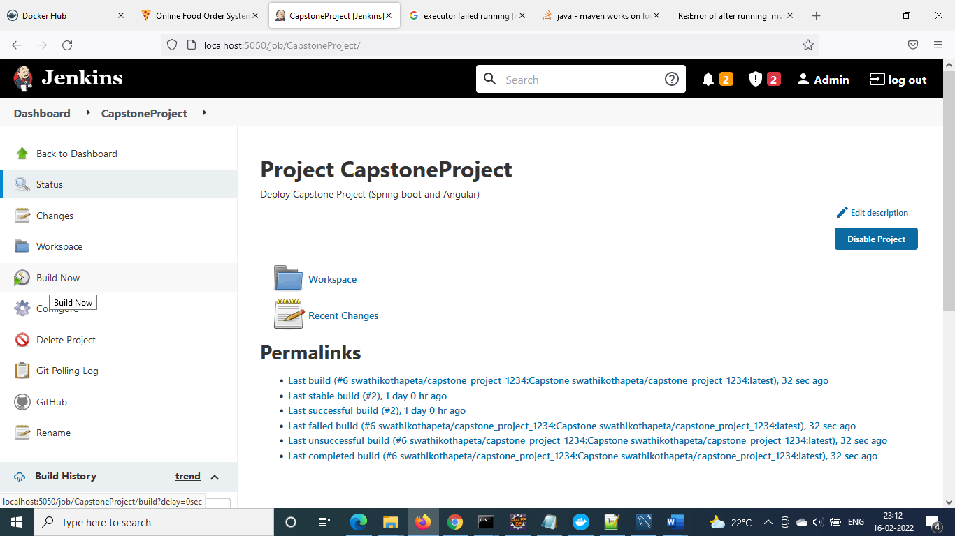

**Admin Login**

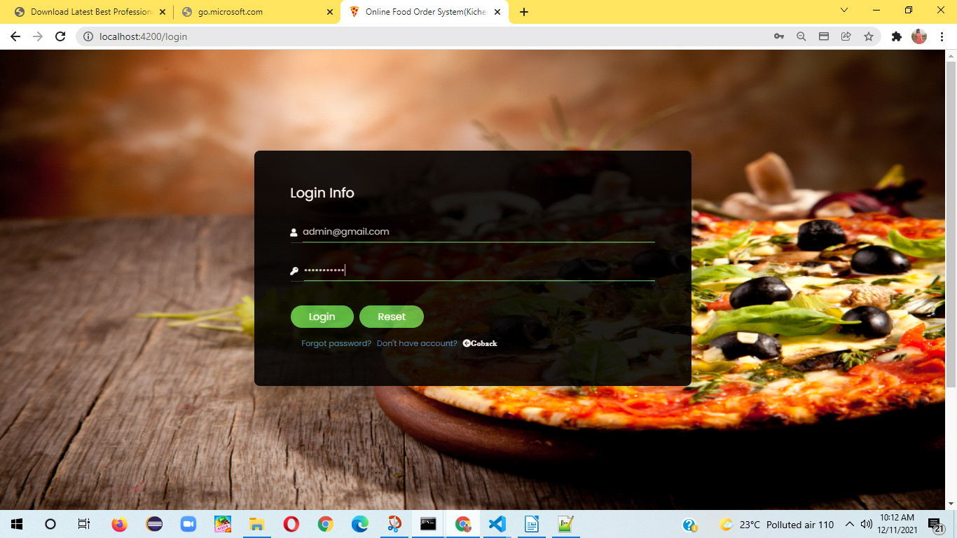

**After Logon admin home will display orders list:-**

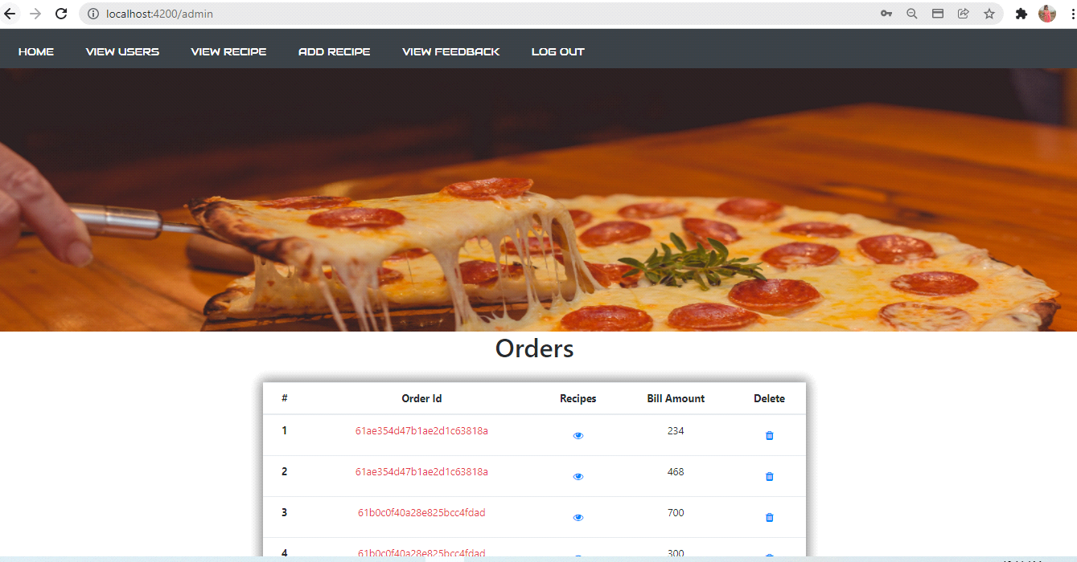

**3**

**Admin Home:**

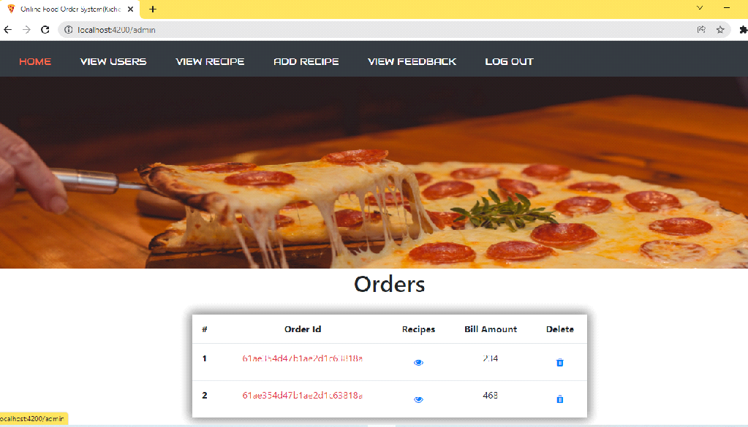

**View users:-**

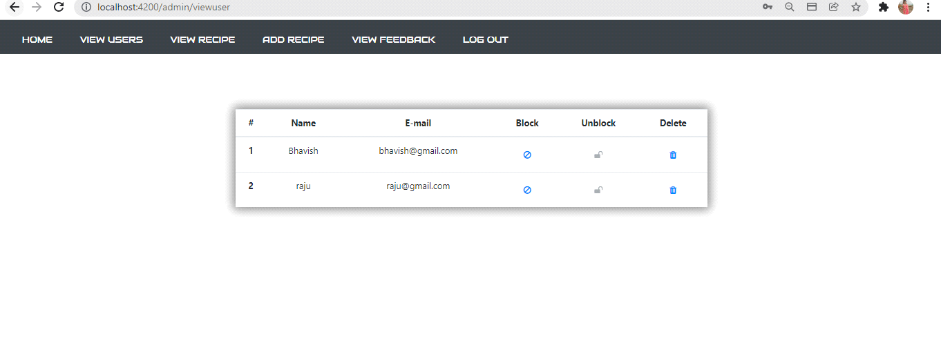

**4**

**Add Recipe**

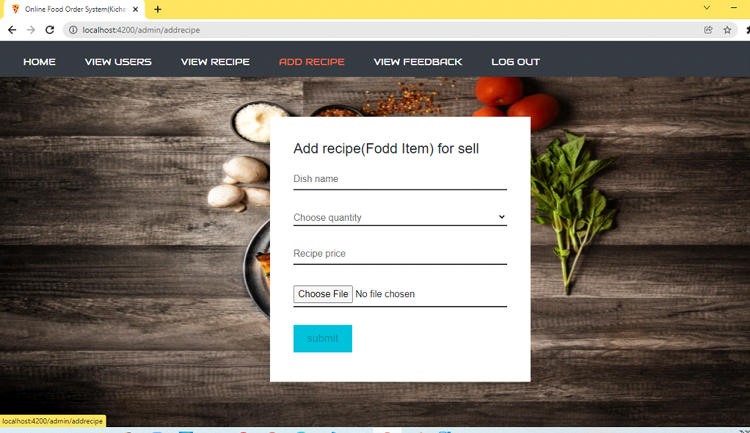

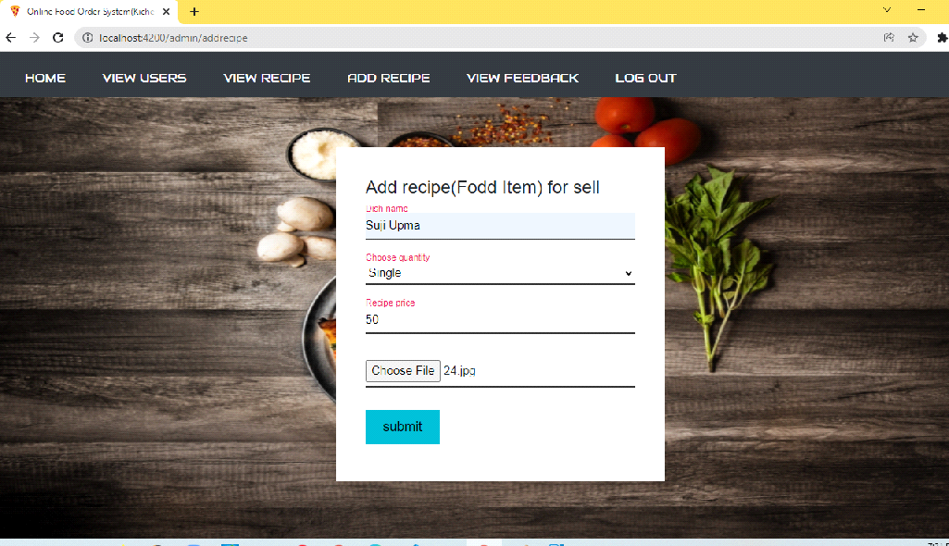

**5**

**view recipe**

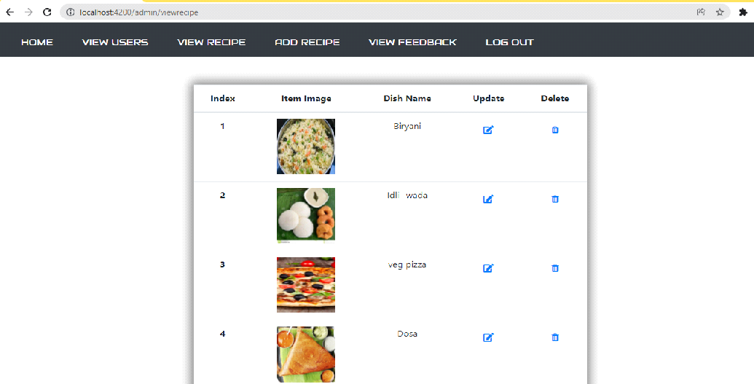

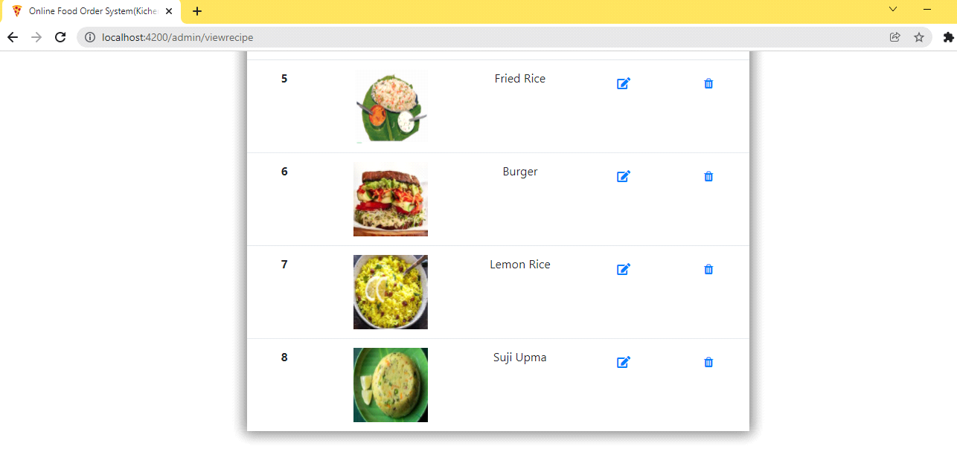

**6**

**View Feed back**

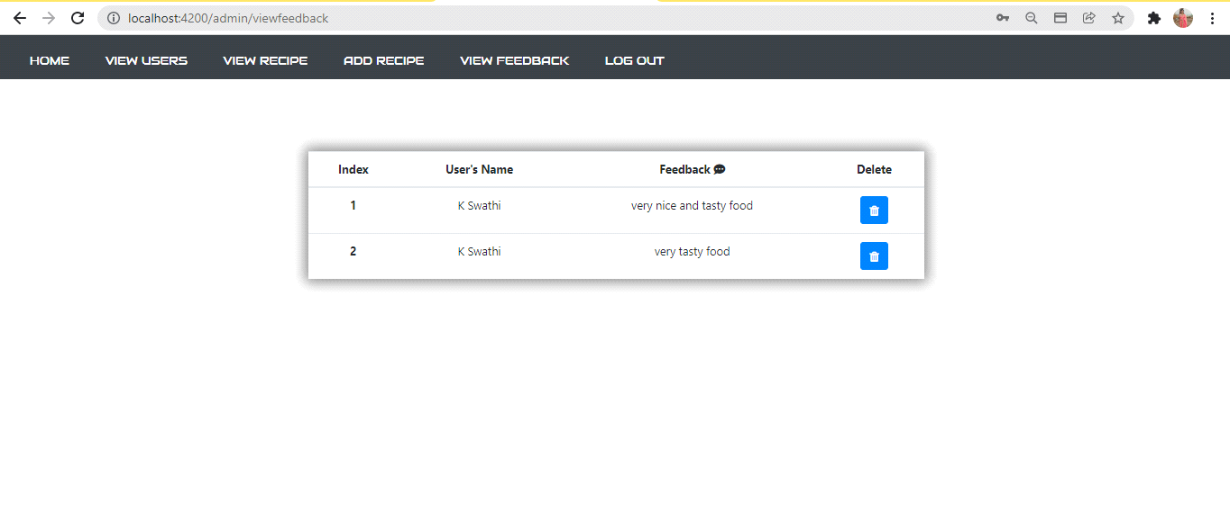

**7**

**User Flows:**

**1)Web home page**

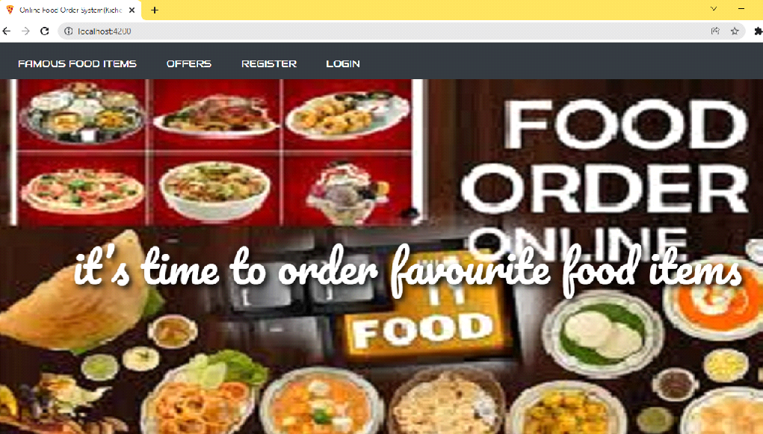

**2) View famous food items**

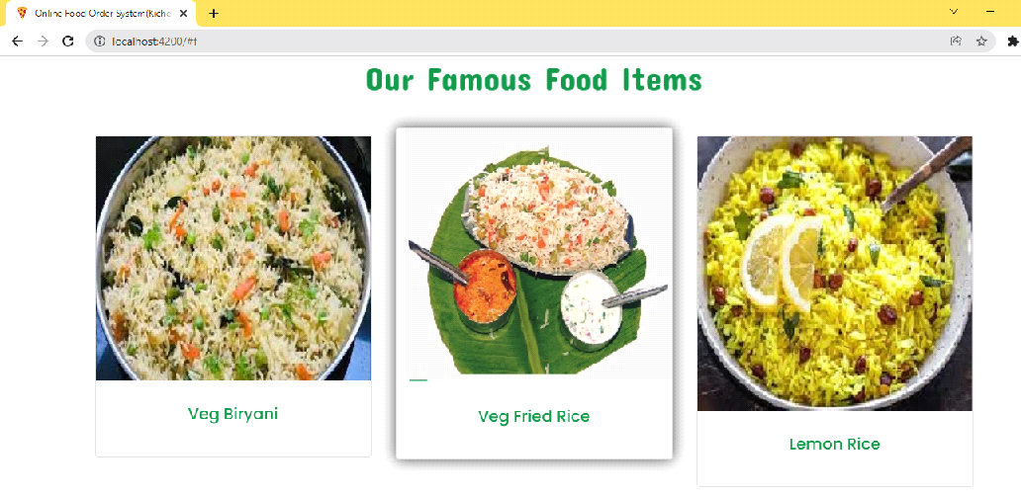

**8**

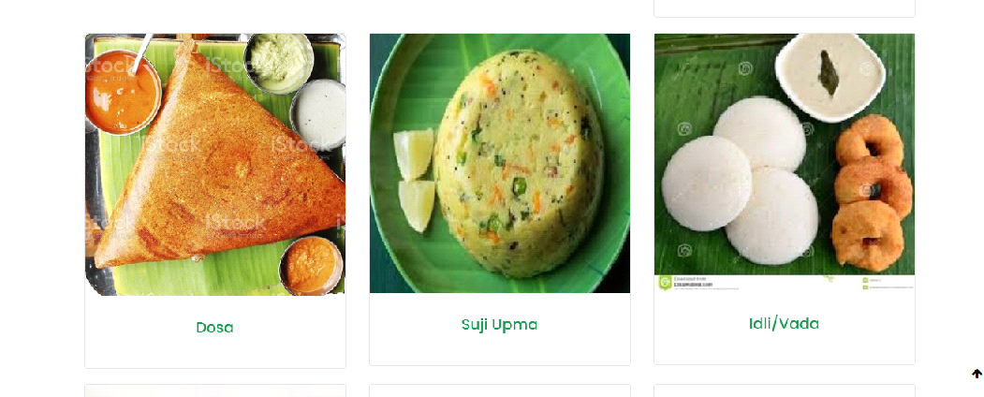

**Check for offers**

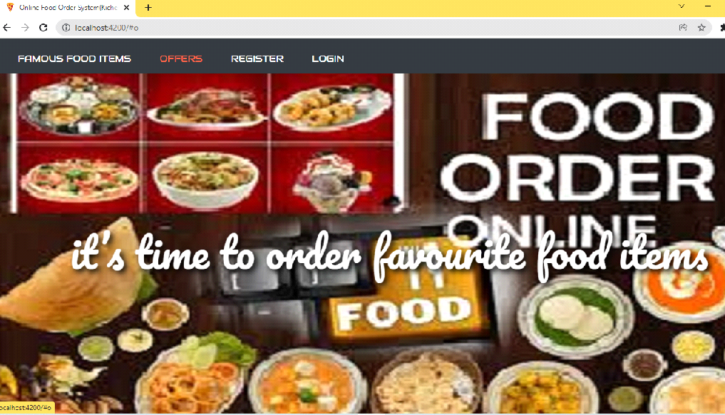

**9**

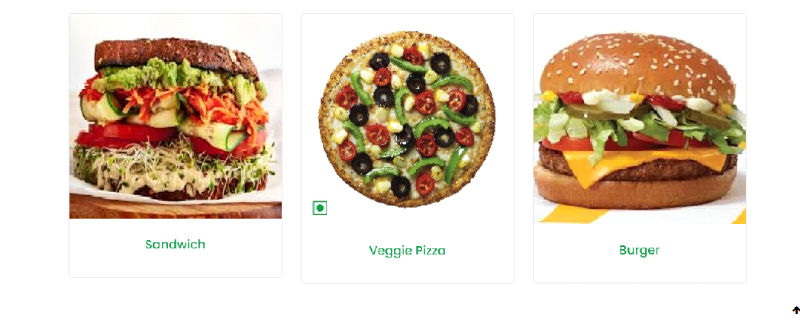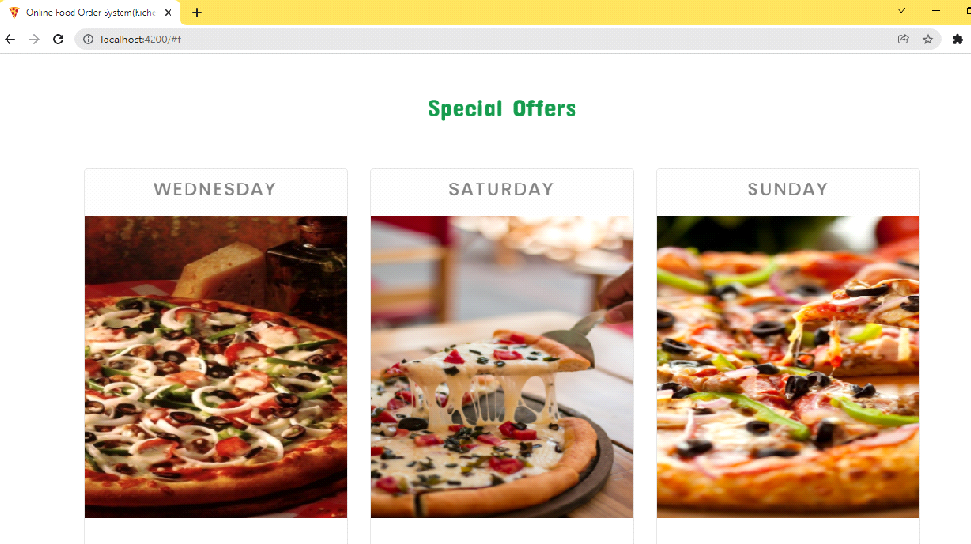

**User Registration (click on register)**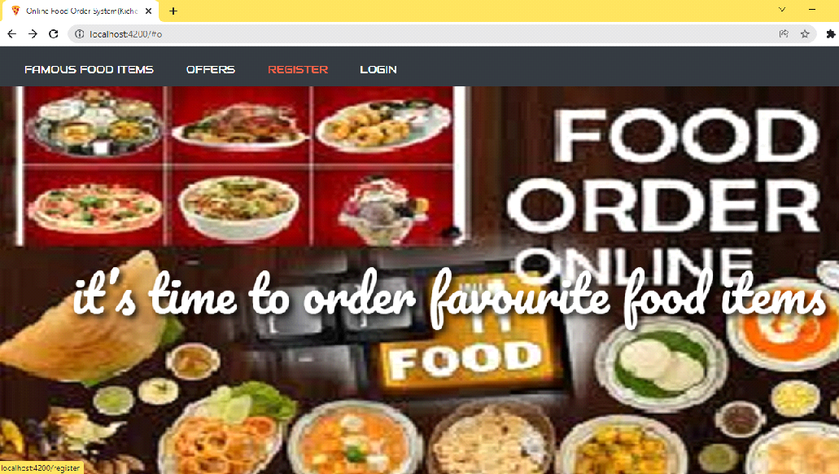

**10**

**Provide User details for Registration**

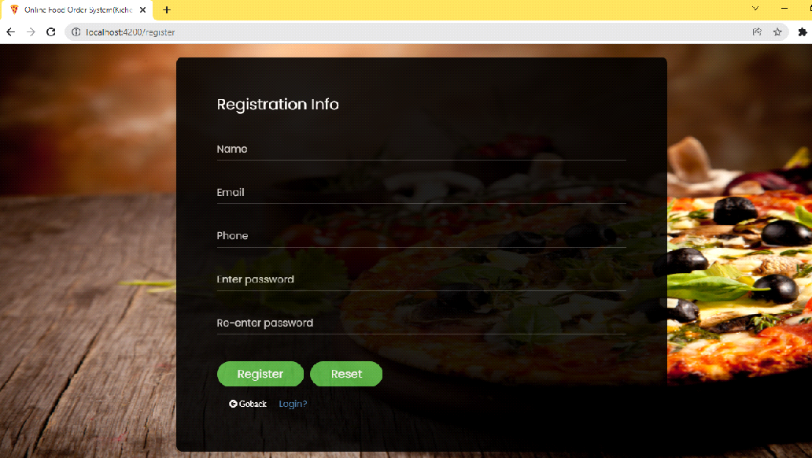

**Validating user form:**

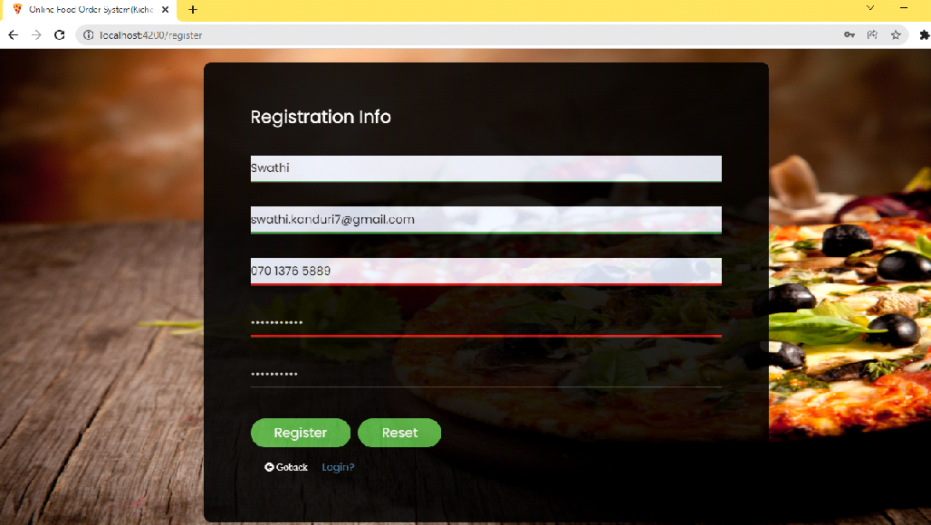

**11**

**After Successful Registration it will redirect to login page**

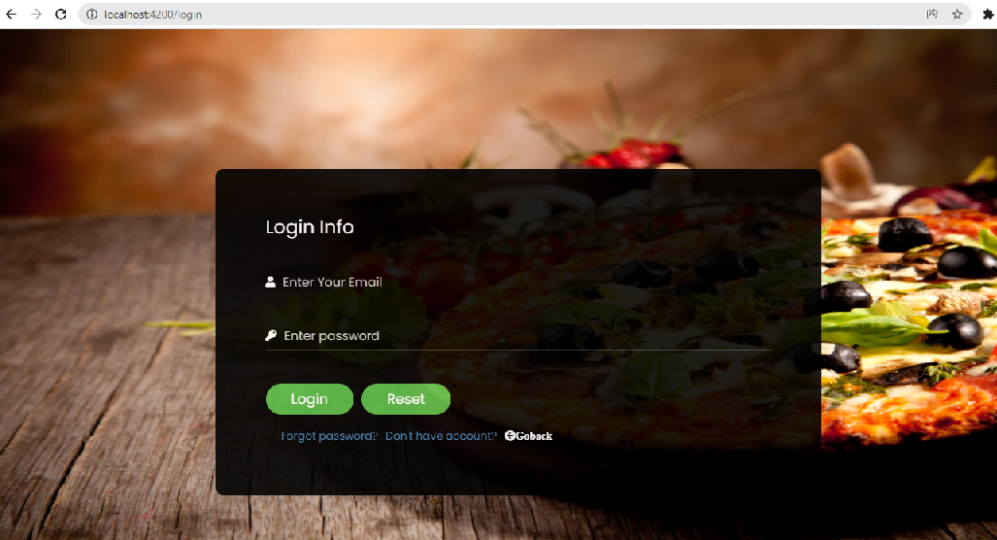

**User Login:-**

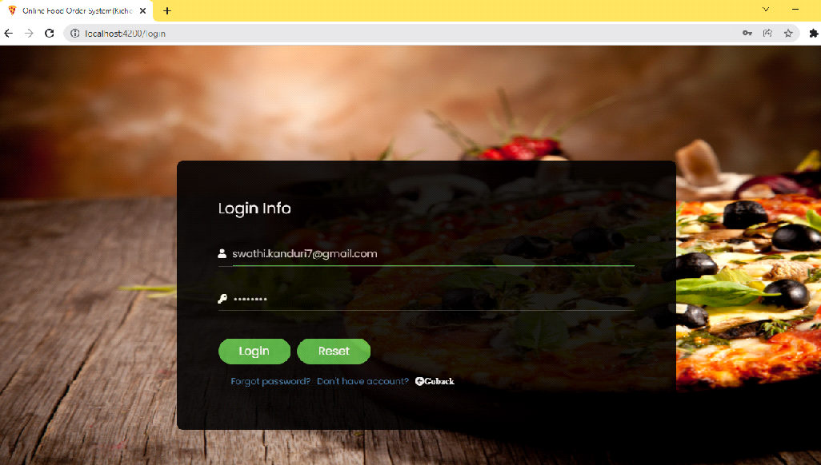

**User home-**

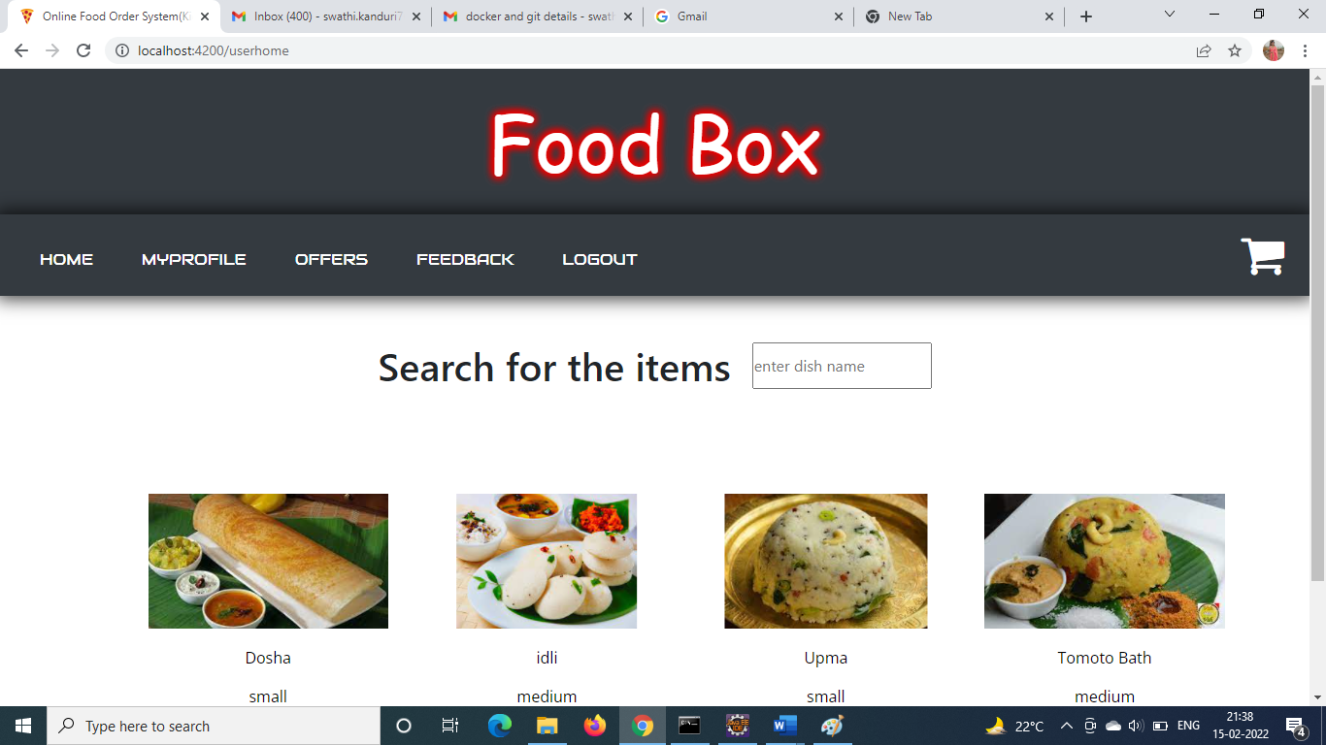

**Search for the items:**

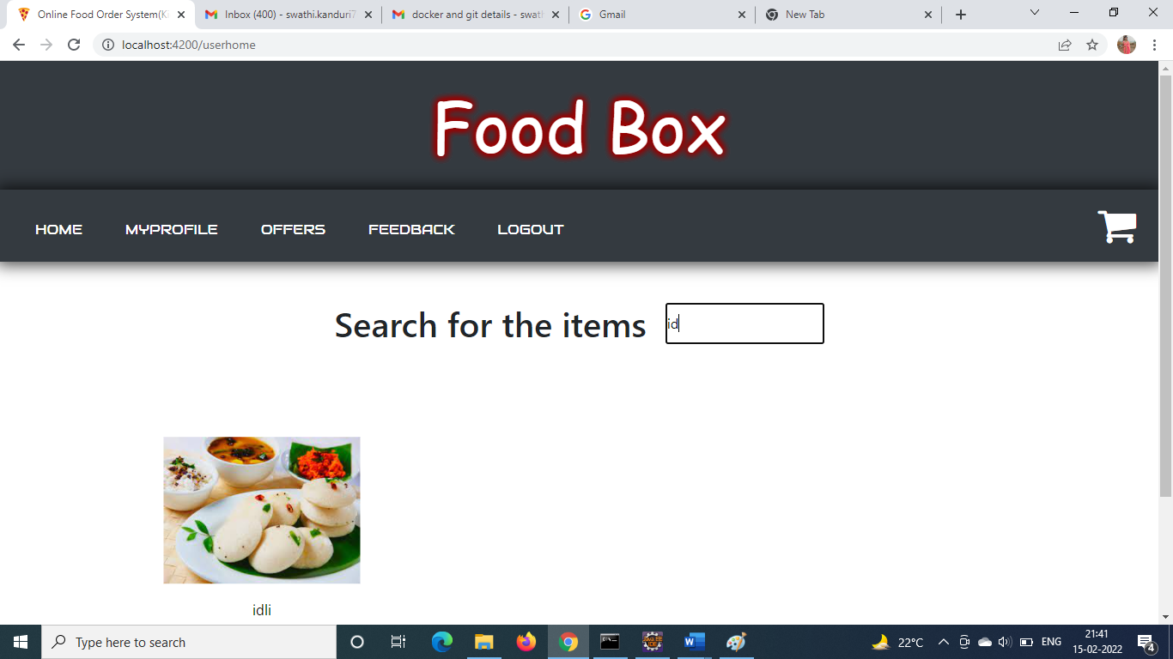

**Buy Now:**

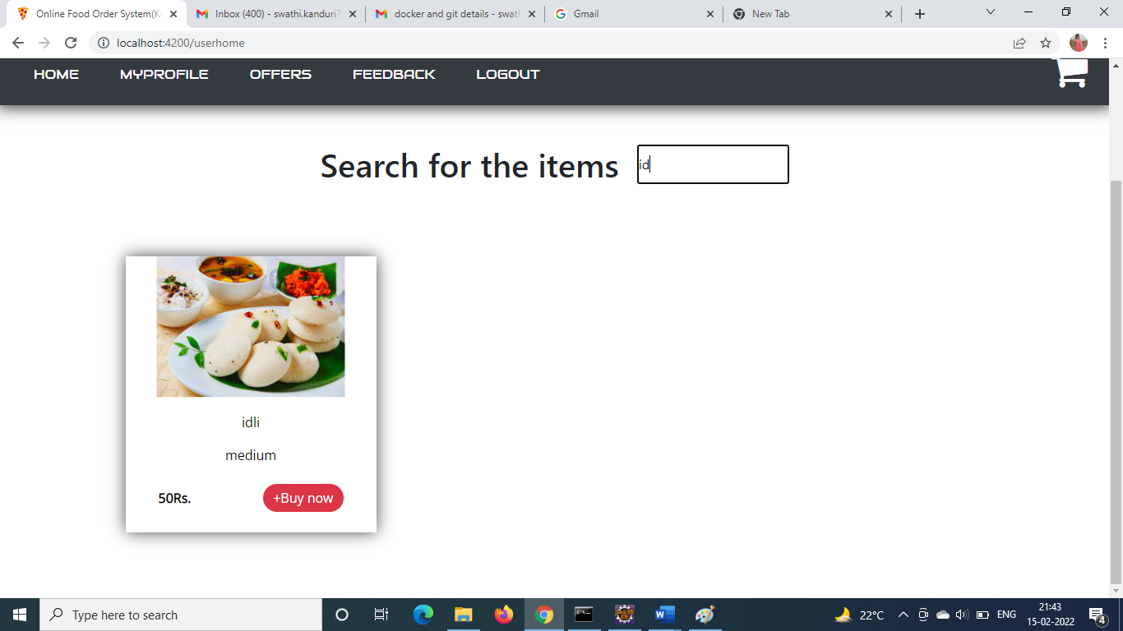

**Go to Cart to check out:**

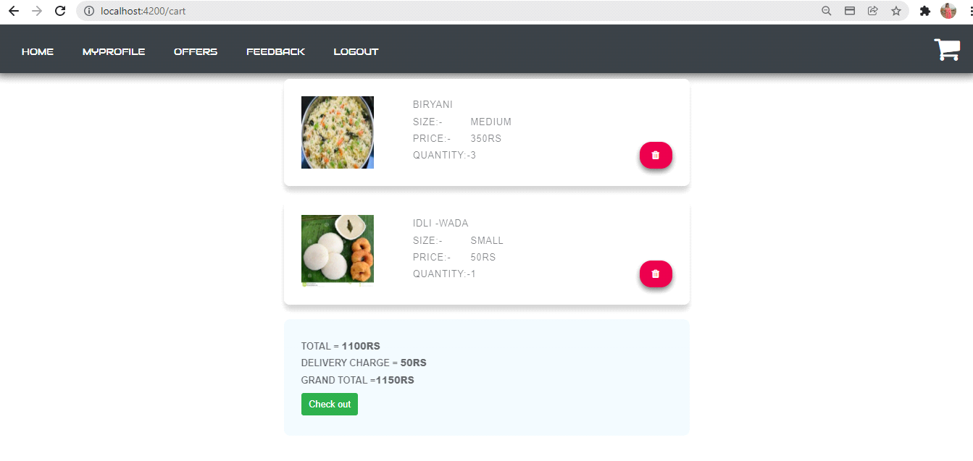

**Click on check out for payment:**

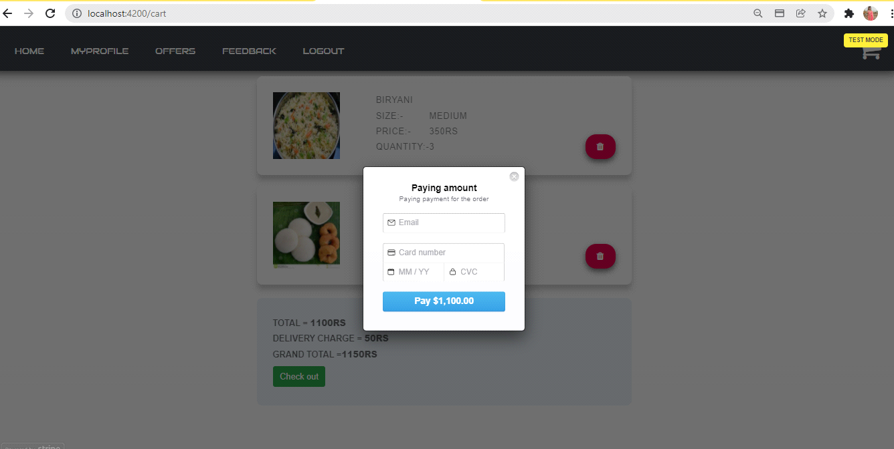

**Provide the details (debit/credit card)**

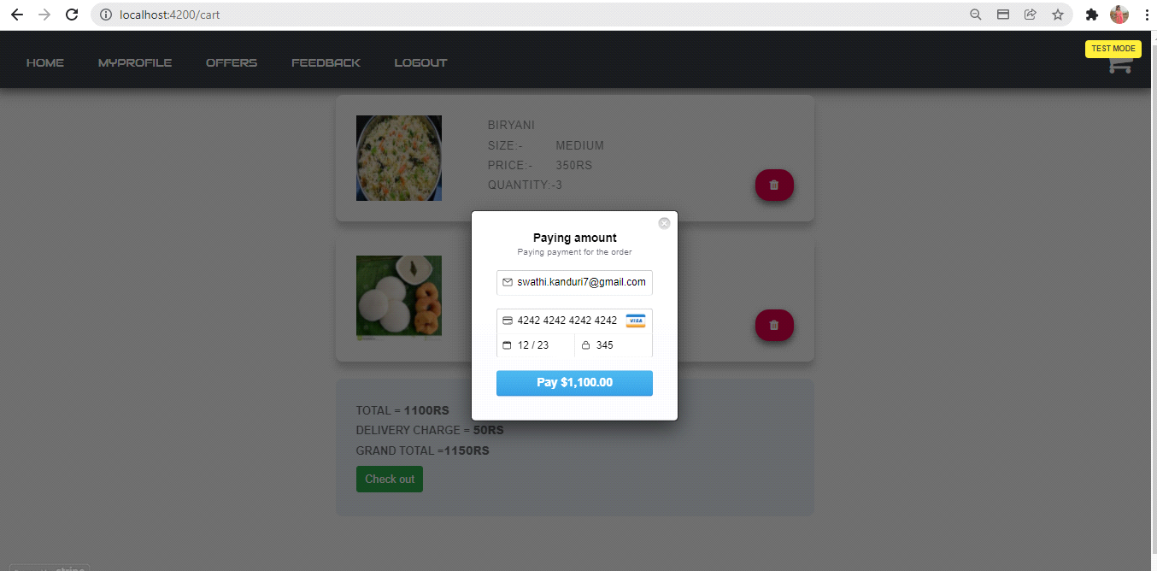

**payment successful:-**

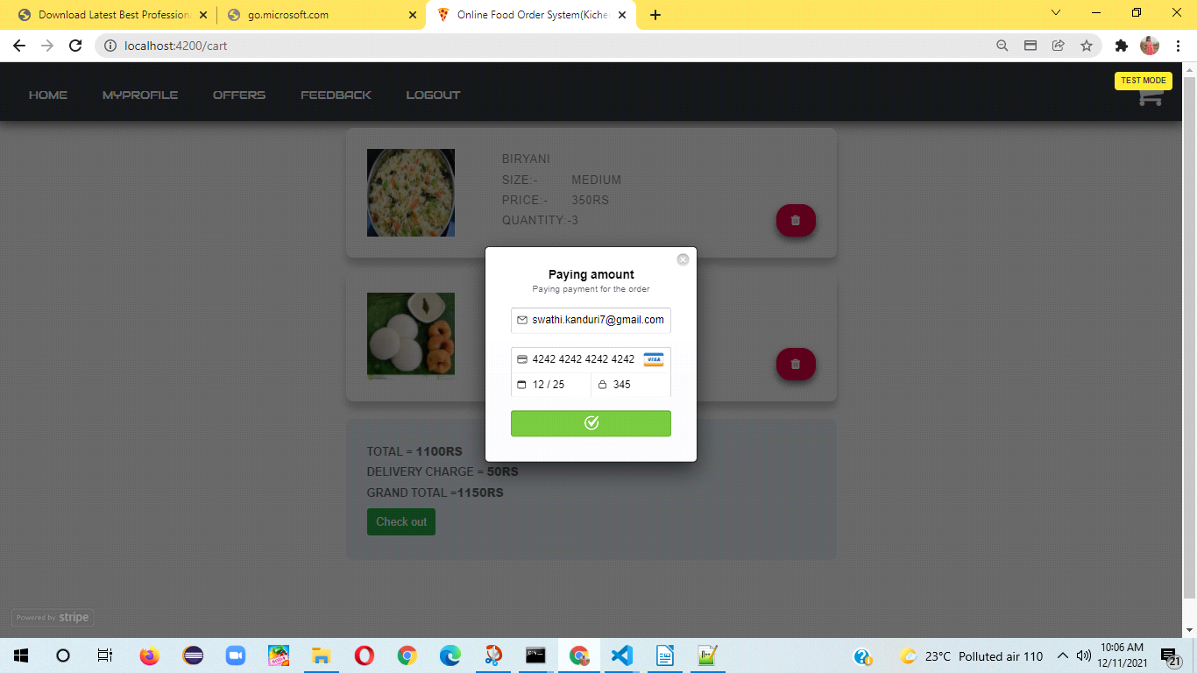

**Placed order successfully Confirmation display:**

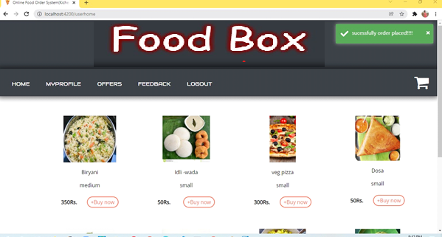

**Click on my profile**

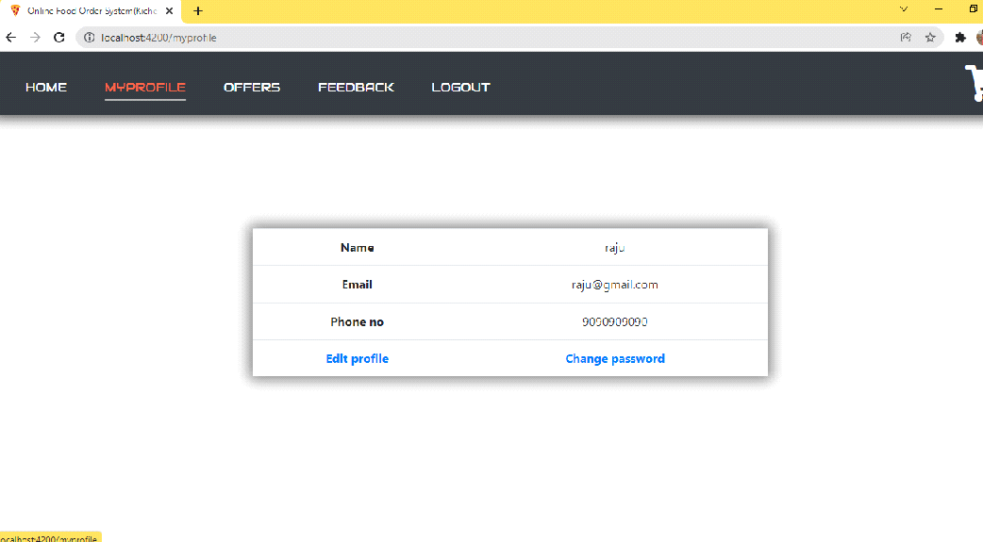

**click on edit profile**

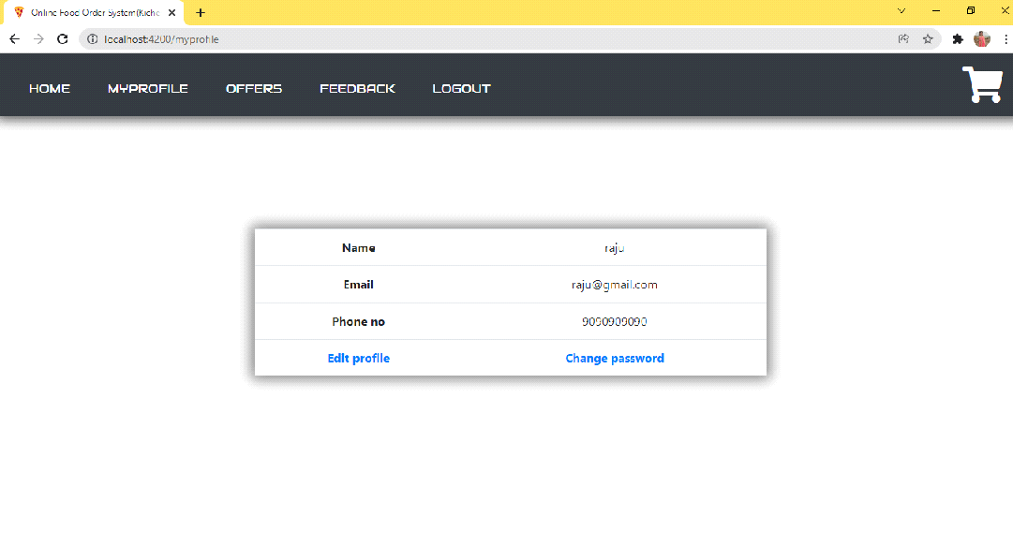

**Edit profile**

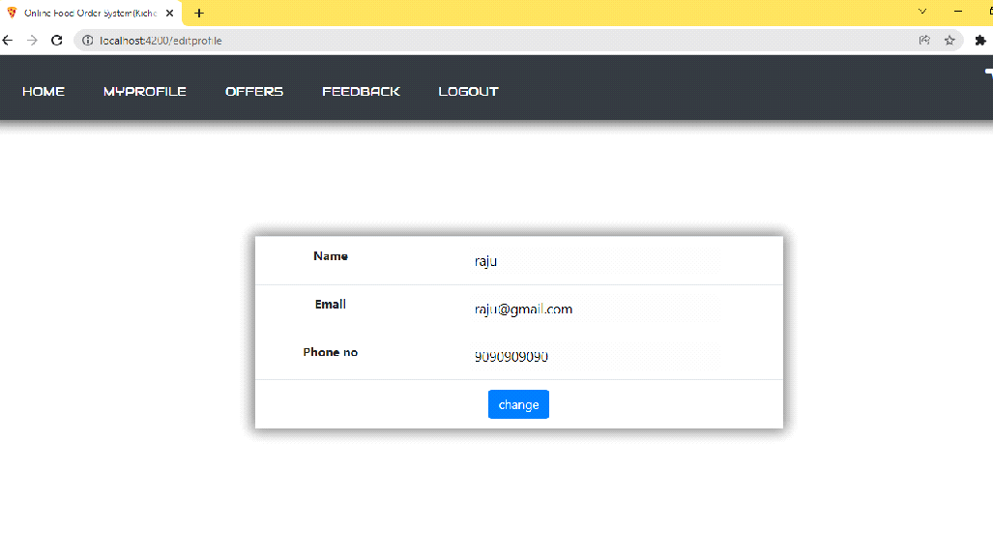**To change password**

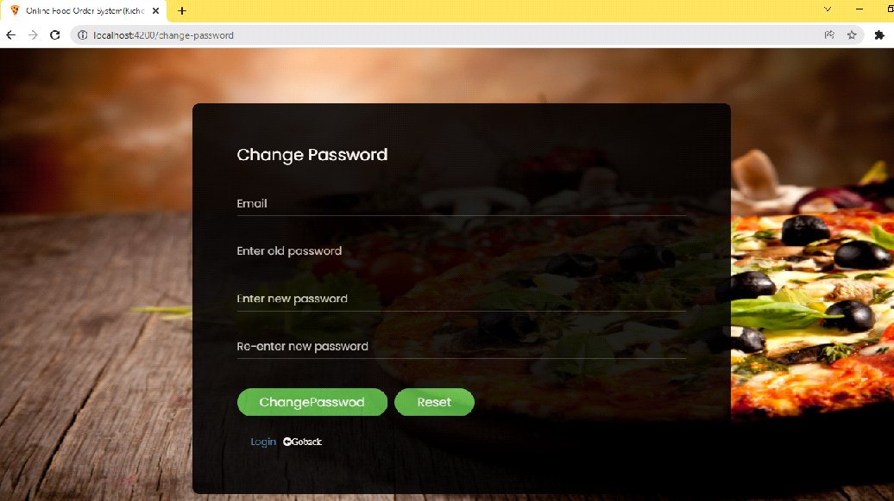

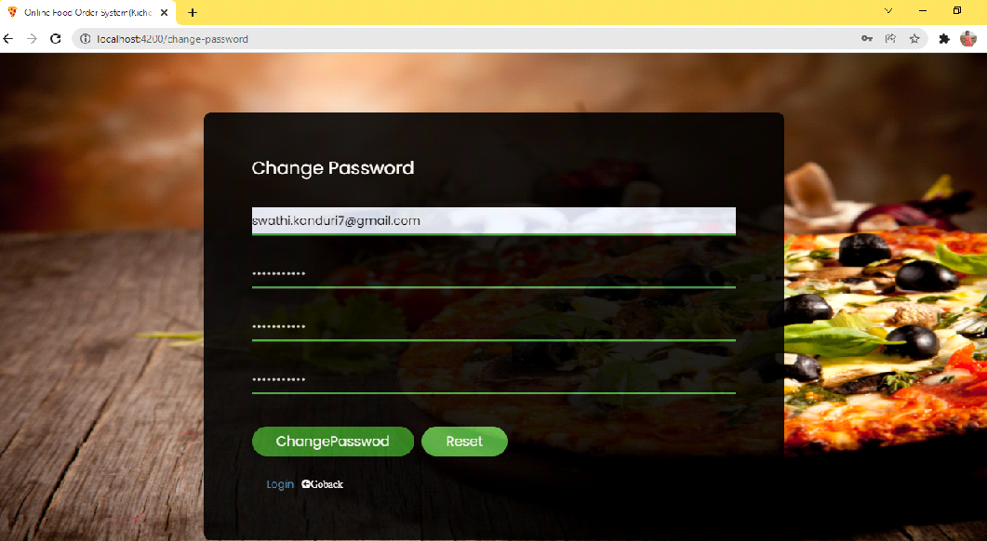

**Forgot password:-**

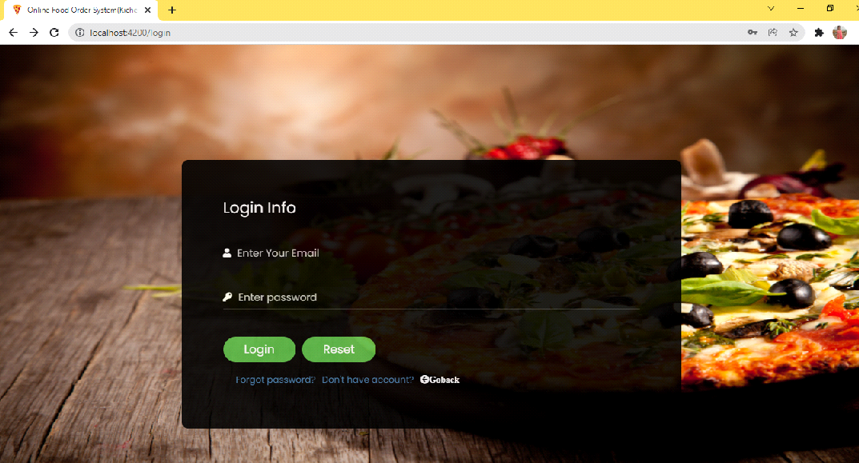

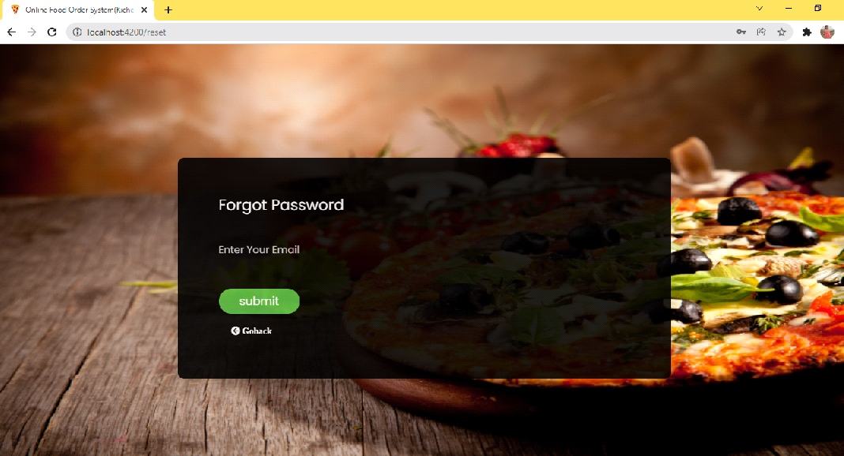

**To provide Feedback:-**

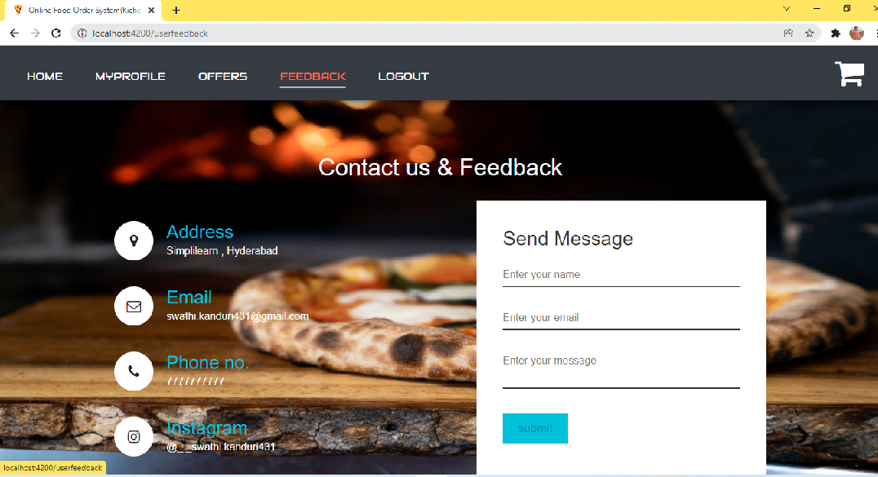

**Contact and feedback form:-**

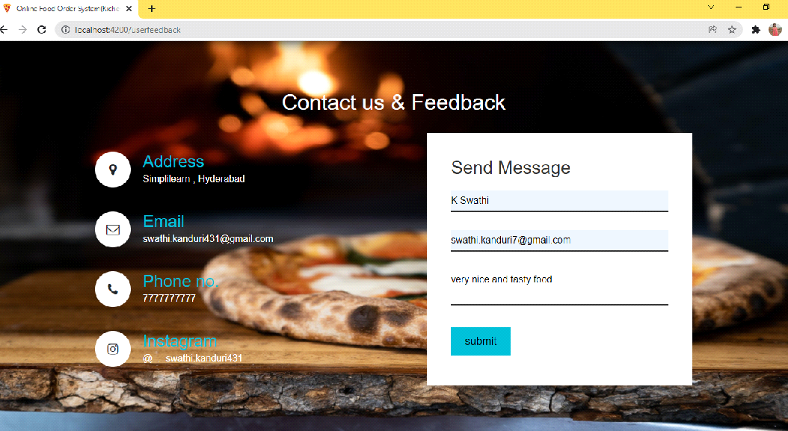

**After adding feedback it will redirect to user home pabe**

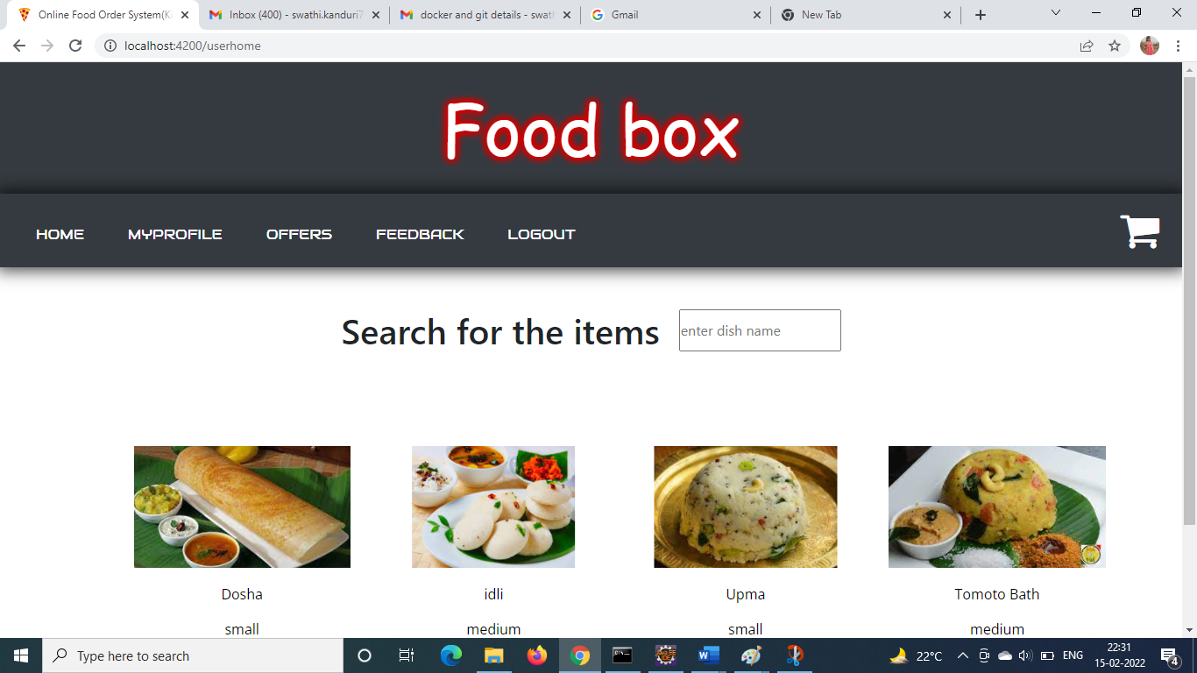

**Logout:-**

